

**Al-Quds University**

**Faculty of Engineering**

**Department of Computer Engineering**

**Software Graduation Project**

**Gaming community**

**Team members:**

**Bashar Shaheen 22010267**

**Safi nafi 22010719**

**Supervised By:**

**Dr. Rushdi Hamamreh**

**Dr.** **Muntaser Abulafi**

**Table of Contents**

Abstract....................................................................................................................4

Chapter 1: Introduction, Objectives, and project scope

1.1 Introduction........................................................................................................5

1.2 Objectives...........................................................................................................6

1.3 Functional Requirements....................................................................................6

Chapter 2: Functional Requirements, Non-Functional Requirements, and System Layers

2.1 Functional Requirements...................................................................................7

2.2 Non-Functional Requirements...........................................................................9

2.3 System Layers...................................................................................................10

Chapter 3: Project Models

3.1 Use Case Diagram.............................................................................................12

3.2 Sequence Diagrams..........................................................................................15 3.3 Class Diagram....................................................................................................17

Chapter 4: Project view

4.1 Project view......................................................................................................18

Chapter 5: Testing

5.1 System testing..................................................................................................32

5.2 Website testing.................................................................................................32

Chapter 6: Conclusion, Key finding and Future Work

6.1 Key finding........................................................................................................33

6.2 Conclusion........................................................................................................33

6.3 Future work......................................................................................................33

# Chapter 7: References and technologies

7.1 Technologies.....................................................................................................34

7.2 References........................................................................................................34

**Table of figures**

Figure 1 - System Layers...............................................................................................................11

Figure 2.1 to 2.6 - Use case diagram.............................................................................................12

Figure 3.1 to 3.3 Use Case Diagram..............................................................................................15

Figure 4 – Class Diagram...............................................................................................................17

Figure 5 - Main Page.....................................................................................................................18

Figure 6 - Login Page ....................................................................................................................19

Figure 7 - Register Page................................................................................................................19

Figure 8 – Help Page.....................................................................................................................20

Figure 9 – giveaway Page..............................................................................................................21

Figure 10 – giveaway profile page................................................................................................21

Figure 11 – my giveaways page....................................................................................................22

Figure 12 – user profile page........................................................................................................22

Figure 13 – add new game page...................................................................................................23

Figure 14 – edit game page..........................................................................................................24

Figure 15 – Banned user's page....................................................................................................25

Figure 16 – chat page....................................................................................................................25

Figure 17 – games control page....................................................................................................26

Figure 18 – email verify page........................................................................................................27

Figure 19 – forget password page................................................................................................27

Figure 20 – reset password page..................................................................................................28

Figure 21 – add new giveaway page.............................................................................................28

Figure 22 – edit giveaway page....................................................................................................29

Figure 23 – not found page...........................................................................................................29

Figure 24 – game group page.......................................................................................................30

Figure 25 – topic page..................................................................................................................31

Figure 26 – notification page........................................................................................................31

Figure 27 - website testing lighthouse..........................................................................................32

**Abstract**

The Gaming Hub App is a platform designed for today's gaming community. It combines key features like user authentication, profile management, and secure account recovery, with a focus on improving community engagement. The app enables real-time messaging in both private and group settings, with group chat controls and a live notification system to keep users informed about community activities. Core functionalities include group gaming, topic discussions, and the ability to contribute comments, enhancing social interaction. Additionally, the app features gaming giveaways and advanced search tools to connect users with other users and gaming groups. With email system for verification, the Gaming Hub App offers a great online gaming experience.

**Chapter 1: Introduction, Objectives, and project scope**

**1.1 Introduction**

The Gaming Hub App emerges as a comprehensive platform, crafted to enhance the digital gaming experience through its array of interactive and community-driven features. It improves the way gamers connect, interact, and engage with each other. The app offers fundamental functionalities such as user registration, login, email verification, and password recovery options, ensuring a secure and accessible entry point for users.

Beyond these essentials, the Gaming Hub App elevates the social aspect of gaming. Users can update their profiles, follow or unfollow fellow gamers, and engage in real-time private or group messaging, complete with group chat controls. The live notifications page keeps users promptly informed about comments, new topics, new giveaways, and updates from followed users, creating a dynamic and interconnected community.

Central to the app's appeal is its focus on collaborative gaming experiences. Admins can create group games, initiate and participate in discussions on various gaming topics, and add comments and interactive environment. The app further enriches user engagement through the creation and participation in game-related giveaways, adding an element of excitement and reward.

For seamless interaction, the app incorporates advanced search functionalities, enabling users to effortlessly find and connect with other gamers and groups. Additionally, its robust email system not only secures accounts but also keeps users informed and engaged, making the Gaming Hub App a nexus for gaming enthusiasts to gather, share, and celebrate their passion for gaming.

**1.2 Project Scope**

* **User registration and verification.**
* **Profile editing.**
* **A member directory with search.**
* **Game pages with information.**
* **Post section with comments.**
* **A real-time community chat, giveaways and notifications.**
* **Responsive design for various devices.**
* **Follow users option.**

**1.3 Objectives**

The primary goal of the Gaming Hub App is to establish a unique and friendly platform for gamers of all kinds. It aims to establish a strong community where users can connect and communicate with other gamers. The objectives include a friendly user interface, ensuring reliable and secure user authentication, introducing real-time communication among users, and providing a platform for sharing gaming experiences and resources. Additionally, the app seeks to enhance user engagement through interactive features like game-related giveaways and group gaming experiences.

**Chapter 2: Functional Requirements, Non-Functional Requirements, and System Layers**

**2.1 Functional Requirements**

**User Authentication and Profile Management:**

* **Authentication:** User can access platform without login but don't have the ability to post, comment, follow, chat with other users, etc...
* **User Roles:** The system should support multiple user roles, including gamers and administrators.
* **Access Rights:** Each user role should have specific permissions and access rights within the system, such as creating groups, giveaways.
* **Account Management:** The system should provide a mechanism for managing user profiles, including account settings and password management.

**Social Interaction and Messaging:**

* **Community Building:** Users should be able to follow and unfollow other users.
* **Private and Group Messaging:** The system should enable users to send live private messages and participate in group chats with advanced chat controls.
* **Notifications:** The app should feature a live notifications system, alerting users about new messages, comments, and activities from following users or groups.
* Search Functionality: The app should include robust search capabilities to find and connect with other gamers, groups, and gaming communities.

**Group Gaming and Discussions:**

* **Group Game Creation:** Admins should be able to create and manage groups of games within the system.
* **Discussion Forums:** The system should allow users to create topics for discussion, contribute comments, and engage in gaming-related conversations.
* **Content Management:** Administrators should be able to manage the content within their groups and discussions.

**Mobile Compatibility:**

* Mobile Device Support: The Gaming Hub App should be compatible with mobile devices, ensuring users can access it on smartphones and tablets.
* Responsive Design: The app should feature a responsive design that adapts seamlessly to different screen sizes and resolutions.
* Full Feature Accessibility: Users should have access to all features and functionalities of the app on mobile devices, ensuring a consistent experience across platforms.

**2.2 Non-Functional Requirements**

**Performance:**

* The system should be responsive and provide fast access to game groups, chats, and other features.
* The system should be able to handle many users' interactions without slowing down or crashing.
* The system should have a low latency and high throughput for sending and receiving messages and other user-generated content.

**Usability:**

* The system should be accessible to users with different levels of technical expertise, including novice and experienced users.
* The system should provide clear and concise instructions for using its features and functionalities.
* The system should have a consistent design and layout across all pages and sections.

**Availability**:

* The system should be available 24/7 to users, with minimal scheduled downtime for maintenance and upgrades.
* The system should be able to handle peak usage times without degrading performance or availability.
* The system should have redundant hardware and network components to ensure high availability and fault tolerance.

**Maintainability:**

* The system should be modular and easily extensible, allowing for the addition of new features and functionalities.
* The system should be easily configurable, allowing for customization to meet specific user requirements.
* The system should have well-documented code and development processes to ensure maintainability and supportability.

**2.3** **System Layers**

Presentation Layer:

The presentation layer is responsible for presenting data to users in a visually appealing and understandable format. This layer deals with the user interface, design, and interaction. It includes elements such as web pages, forms, and menus, which allow users to interact with the system. The presentation layer is crucial for providing a good user experience and ensuring that users can easily access and use the system.

Application Layer:

The application layer is responsible for implementing the system's business logic and functionality. This layer is where the actual processing of data takes place. It is responsible for executing commands, handling data, and managing system resources. The application layer interacts with the presentation layer, the business layer, and the database layer to provide a seamless user experience.

Business Layer:

The business layer is responsible for defining the rules and logic of the system. It is the layer where the business logic is implemented. This layer handles the validation of data, authorization of users, and enforcement of business rules. The business layer interacts with the presentation layer, the application layer, and the database layer to ensure that data is processed correctly and efficiently.

Database Layer:

The database layer is responsible for managing the storage and retrieval of data. This layer interacts with the application layer to manage the flow of data between the system and the database. It provides the storage and retrieval of data using various database management systems, such as MySQL, Oracle, and Microsoft SQL Server. The database layer is critical for ensuring data integrity, security, and consistency within the system.

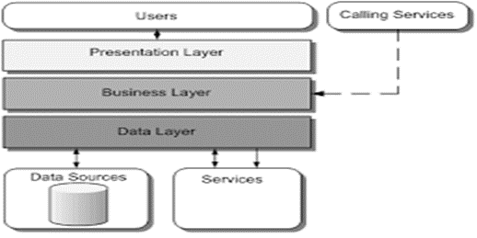

*Figure 1- System Layers*

# **Chapter 3: Project Models**

## **3.1 Use Case Diagram:**

The purpose of a use case diagram in UML is to demonstrate the different ways that a user might interact with a system

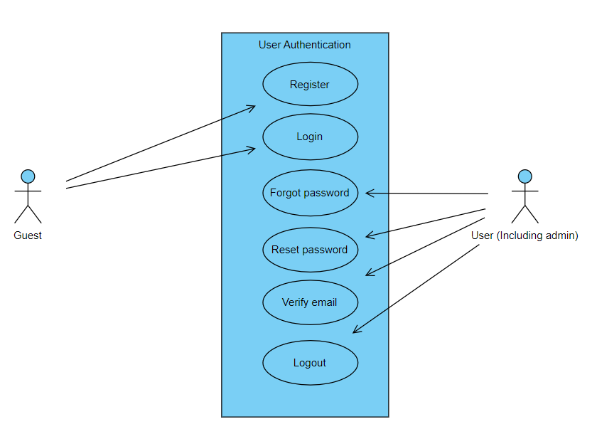

*Figure 2.1 - Use Case Diagram*

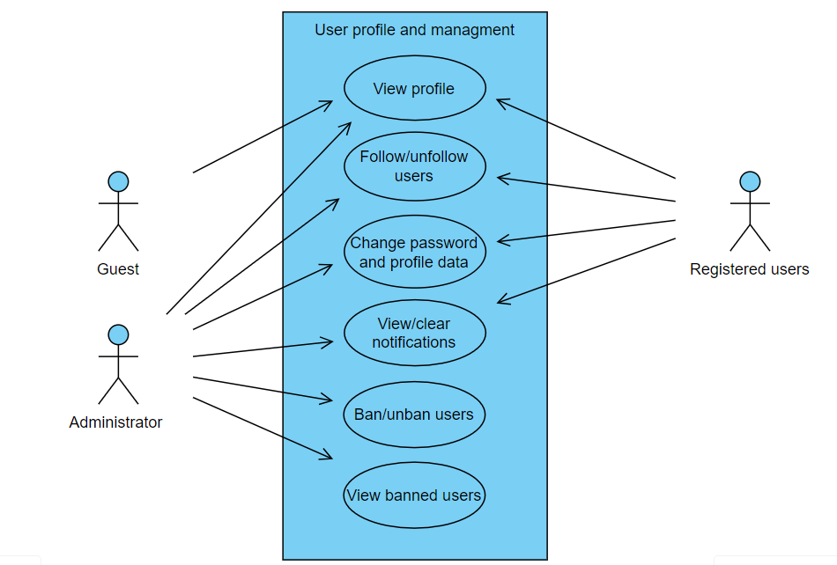

*Figure 2.2 - Use Case Diagram*

## 

## *Figure 2.3 - Use Case Diagram*

## 

*Figure 2.4 - Use Case Diagram*

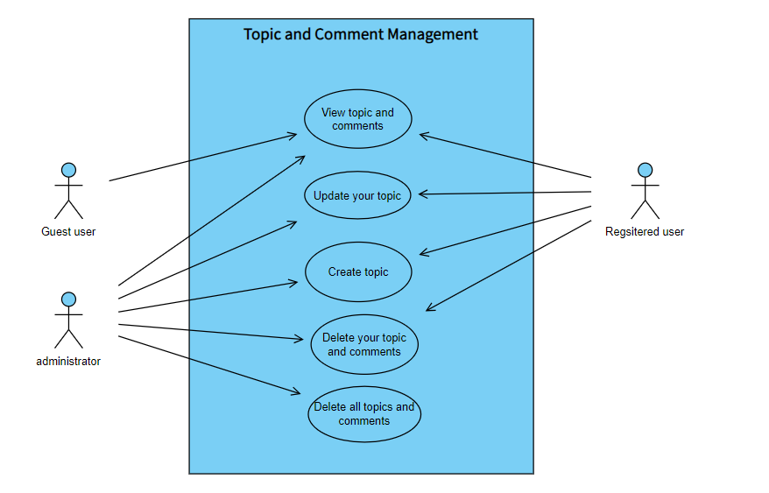

*Figure 2.5 - Use Case Diagram*

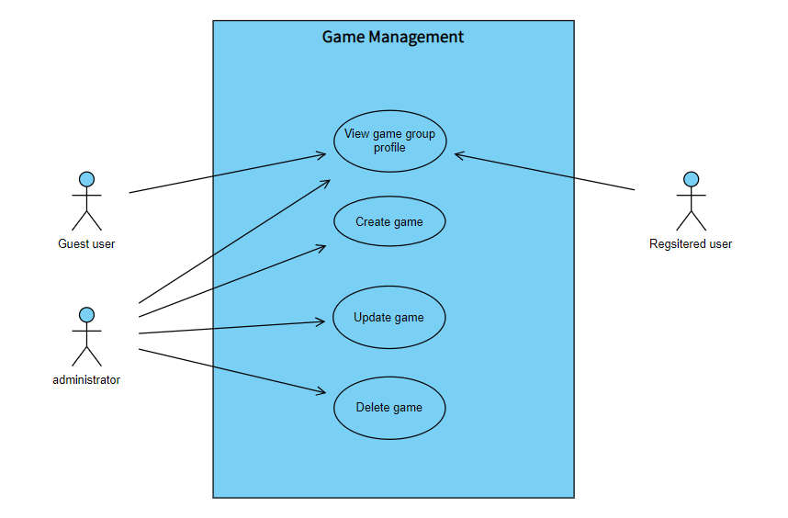

*Figure 2.6 - Use Case Diagram*

## **3.2 Sequence Diagrams:**

A popular dynamic modeling solution in UML because they specifically focus on lifelines, or the processes and objects that live simultaneously, and the messages exchanged between them to perform a function before the lifeline ends.

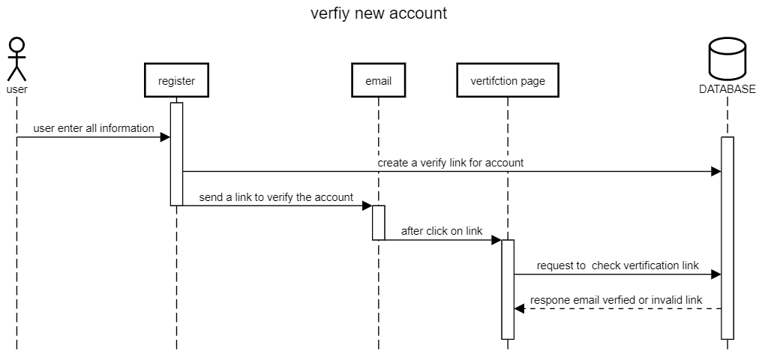

*Figure 3.1 -* *Sequence Diagram*

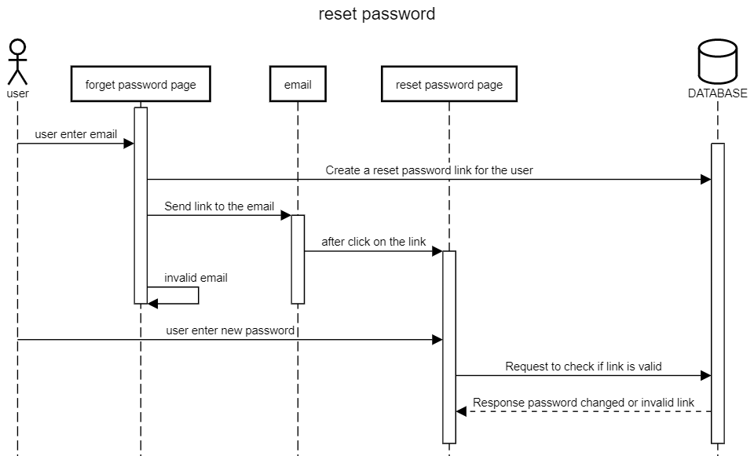

*Figure 3.2 - Sequence Diagram*

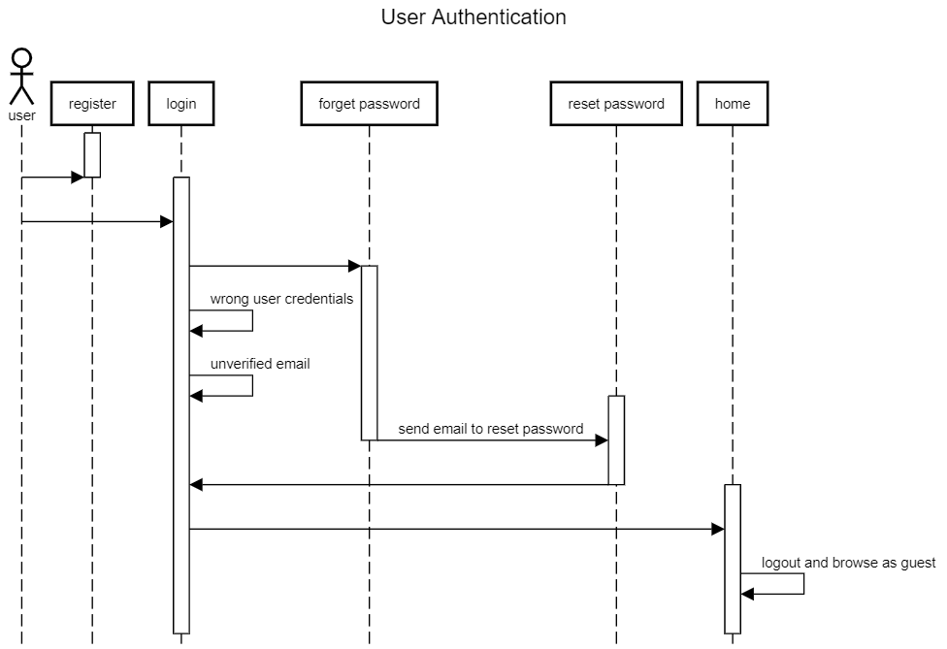*Figure 3.3 - Sequence Diagram*

**3.3 Class Diagram:**

Here we found all classes we used in the app and the relation between them.

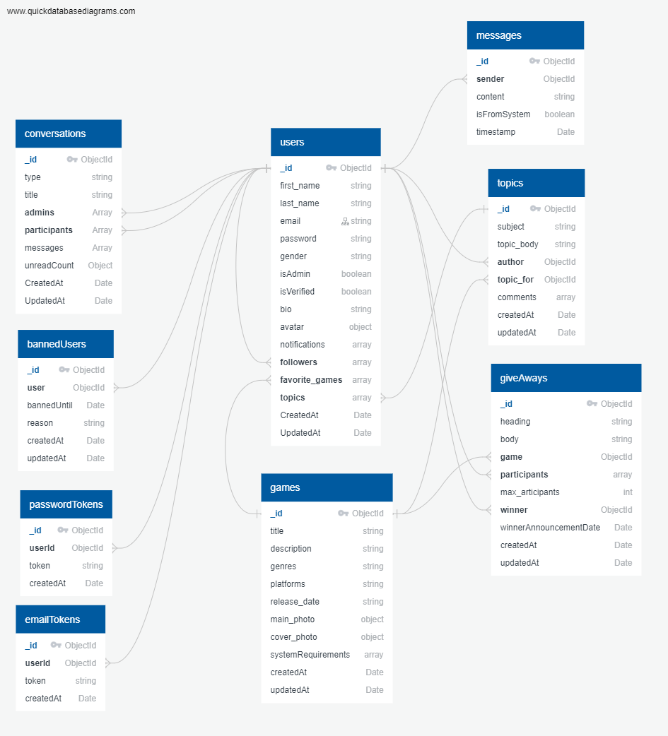

*Figure 4 – Class Diagram*

**Chapter 4: Project Views**

**Main Page:**

This page represents the first page that the user gets to see open the website

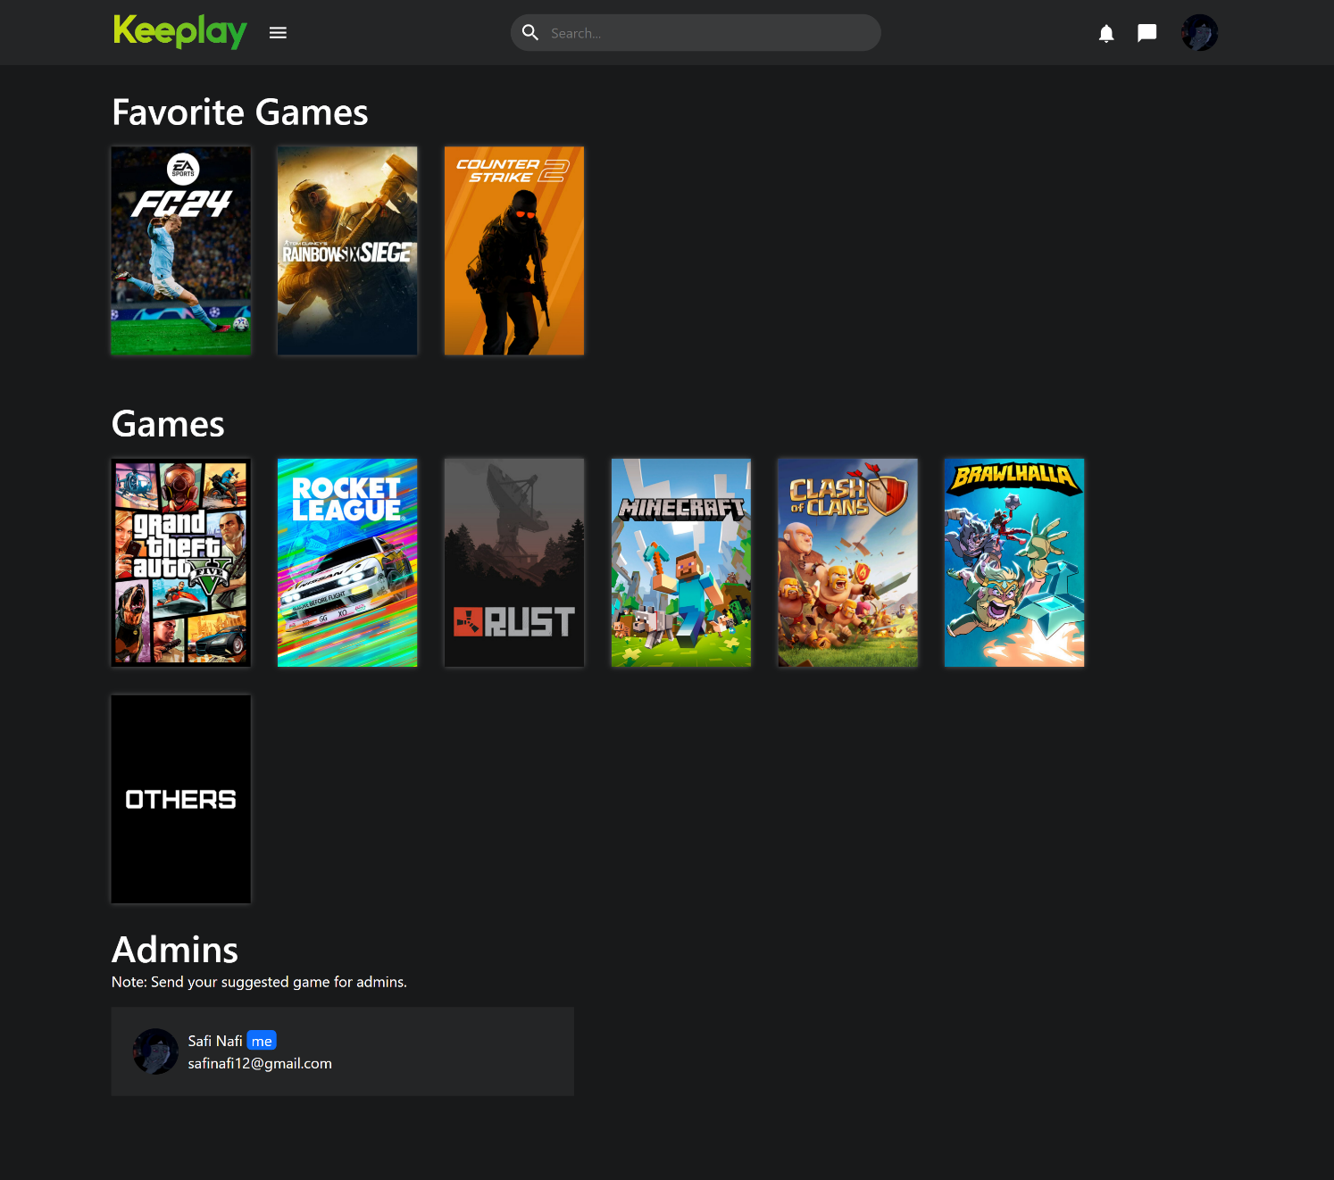*Figure 5 - Main Page*

**Login Page:**  
This page represents the login page where the users enter their credentials, if they are correct, they are granted access according to their rule.

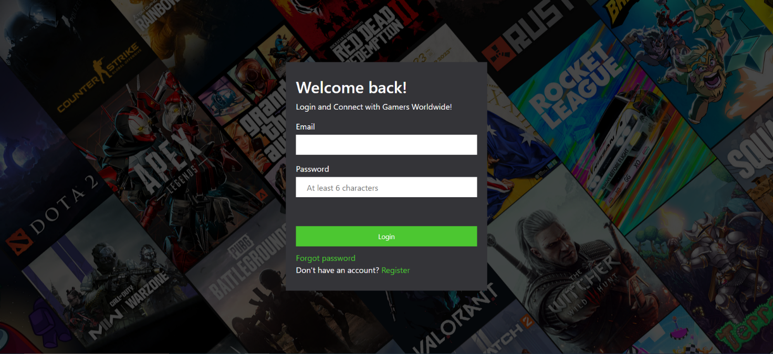*Figure 6 - Login Page*

**Register Page:**  
This page represents the register page where the users enter new credentials, if their email is not used, they are granted registered new account

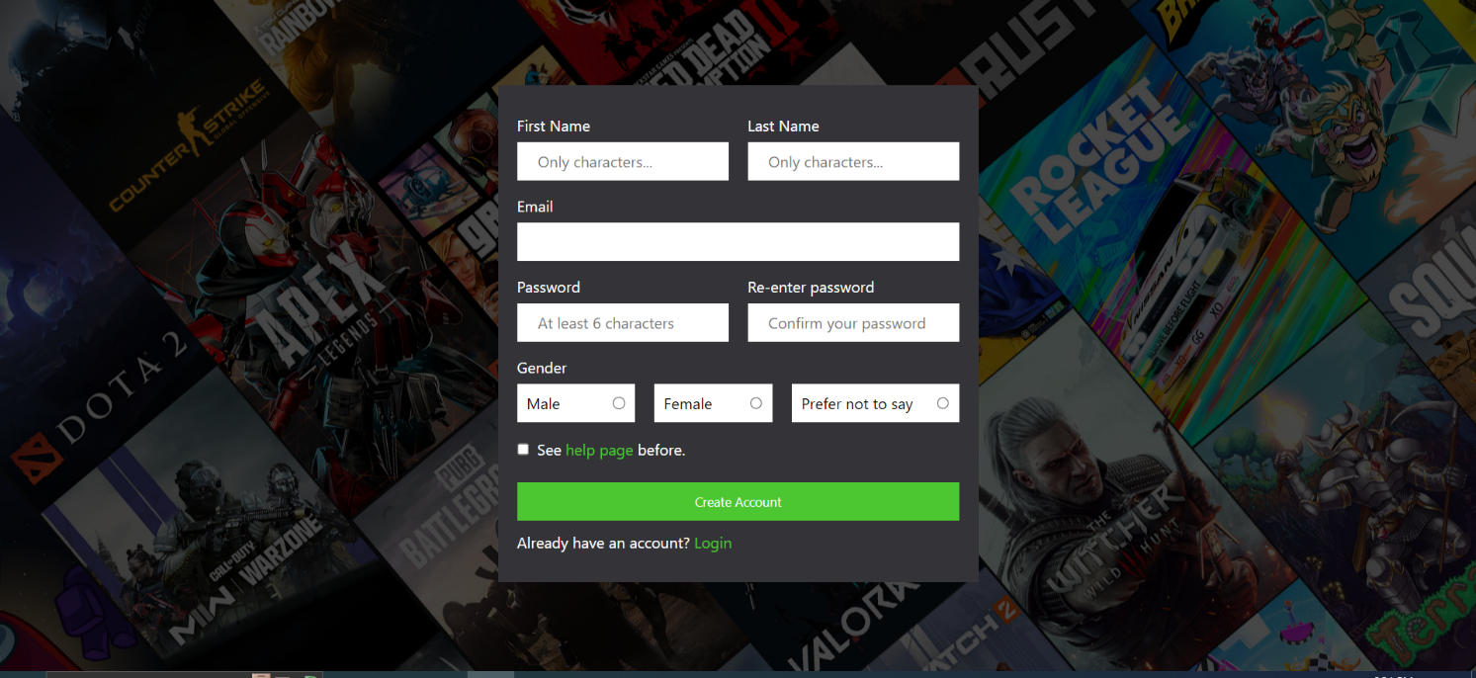*Figure 7 - Register Page*

**Help Page:**

This page represents the rules and how to use the website.

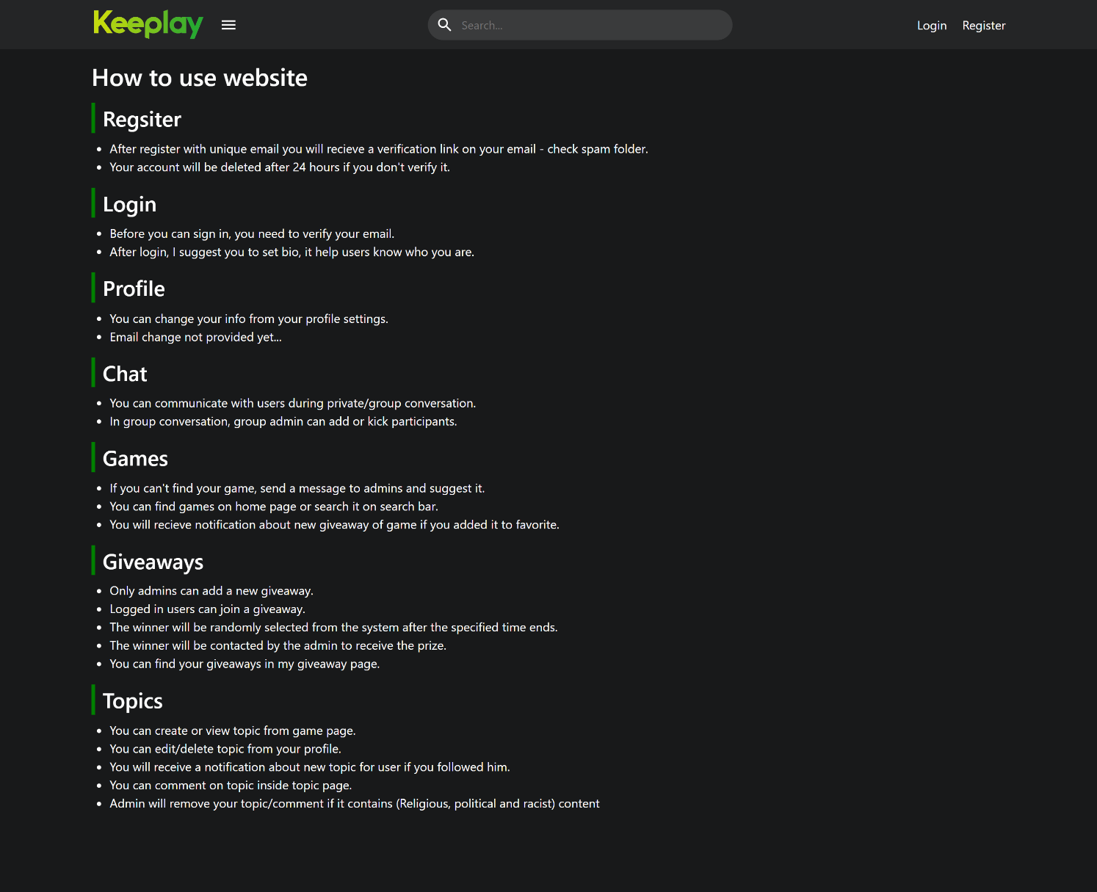*Figure 8 – Help Page*

**Giveaway profile page:**

This page represents all valid giveaways with filter based on game.

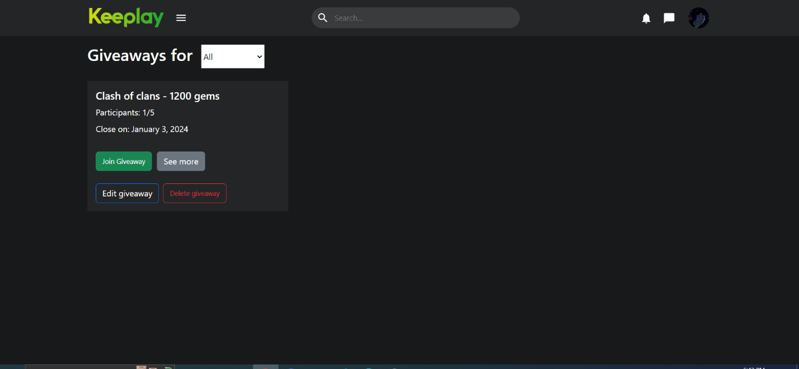*Figure 9 – giveaway Page*

**Giveaway Page:**

This page presents full information about specific giveaway.

.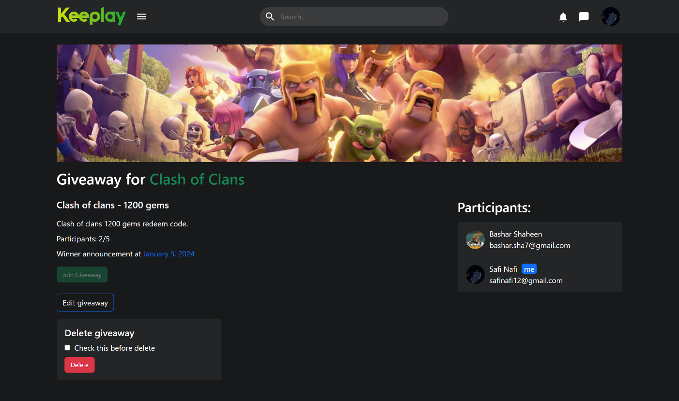*Figure 10 – giveaway profile page*

**My giveaways page:**

This page represents all previous giveaways for a current user.

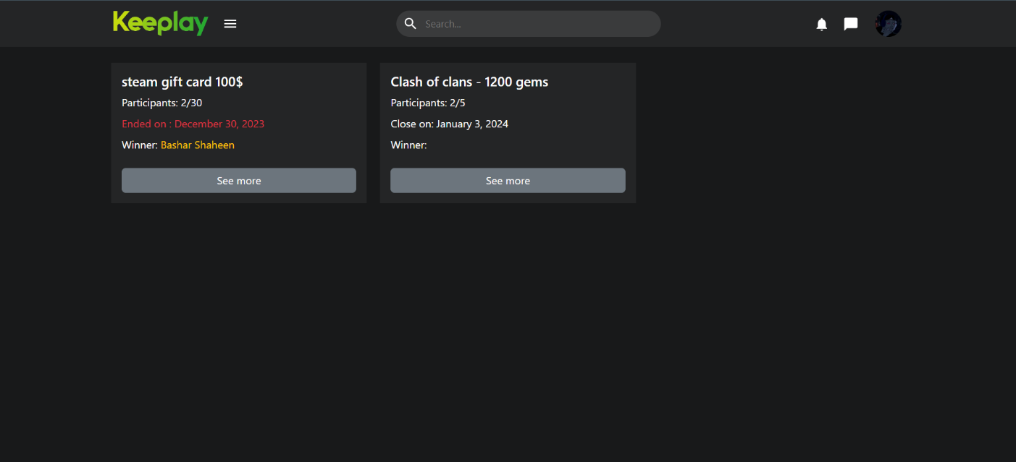

*Figure 11 – my giveaways page*

**User profile page:**

This page represents all information about a specific user.

* With edit profile button for current user
* And follow/unfollow, with contact for other users
* And ban/unban for admin

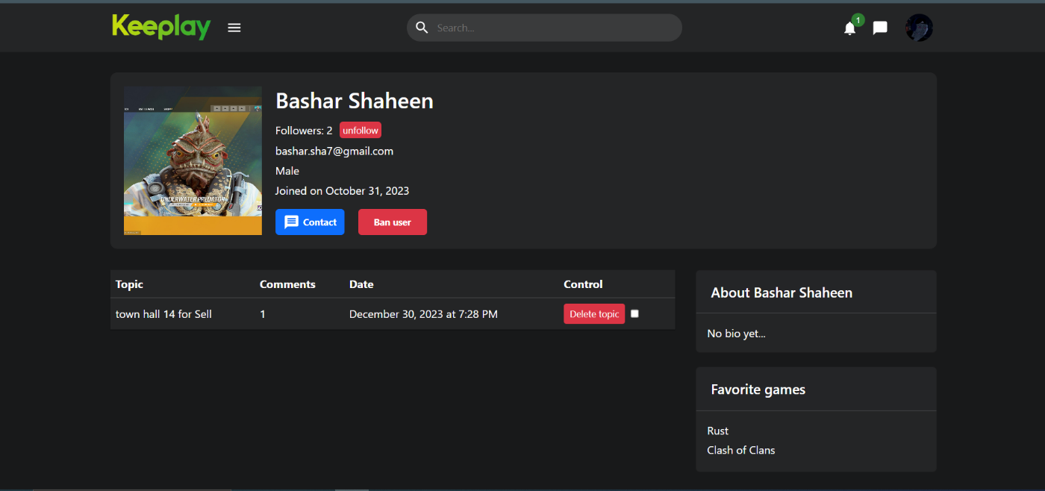

*Figure 12 – user profile page*

**Add new game page:**

This page is only for admins to add new game.

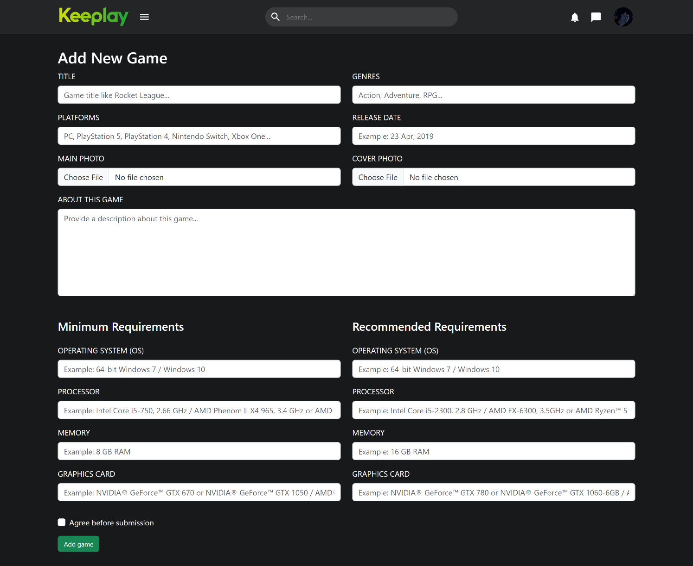*Figure 13 – add new game page*

**Edit game page:**

This page is only for admins to update game information.

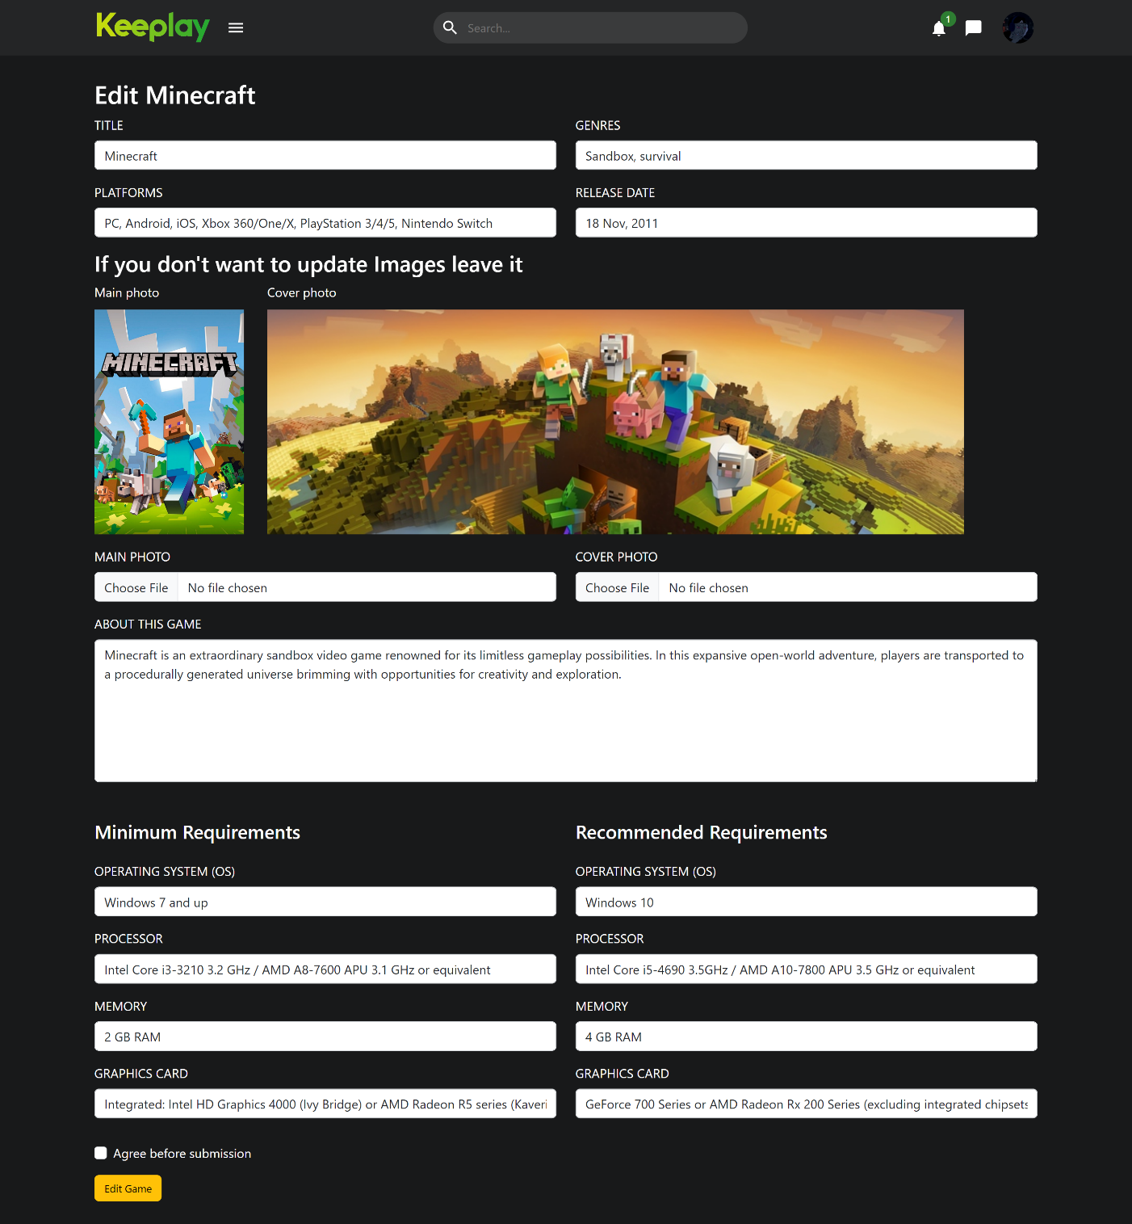

*Figure 14 – edit game page*

**Banned users page:**

This page is only for admins to view banned users or unban them.

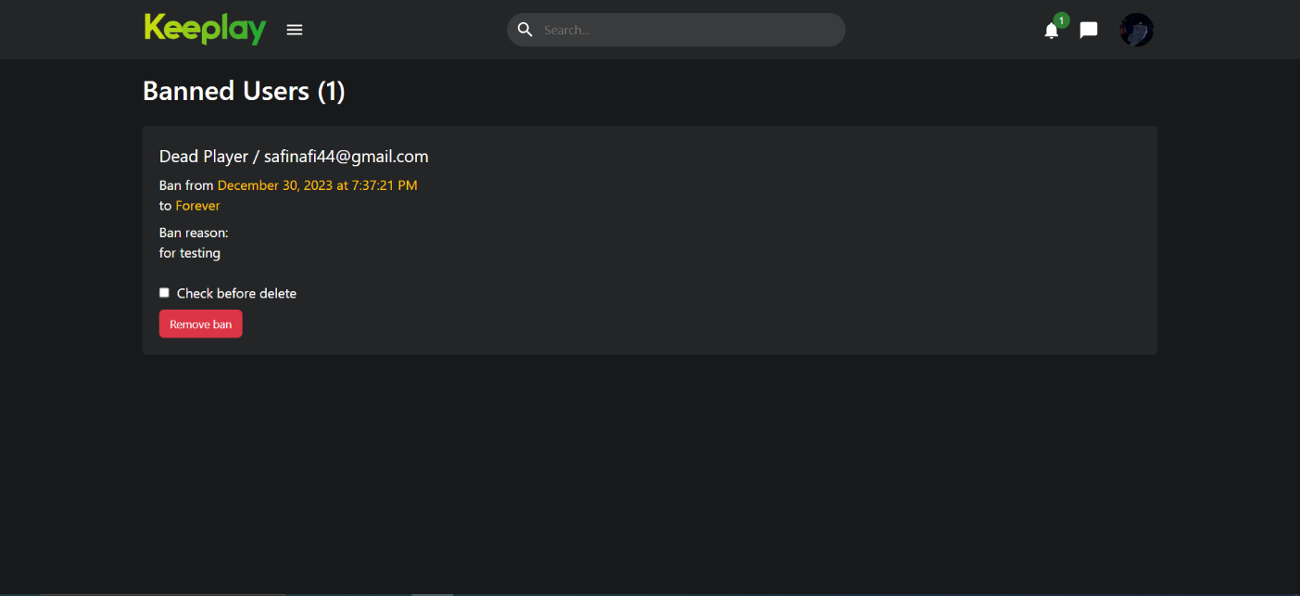

*Figure 15 – Banned users page*

**Chat page:**

This page is private and group chats.

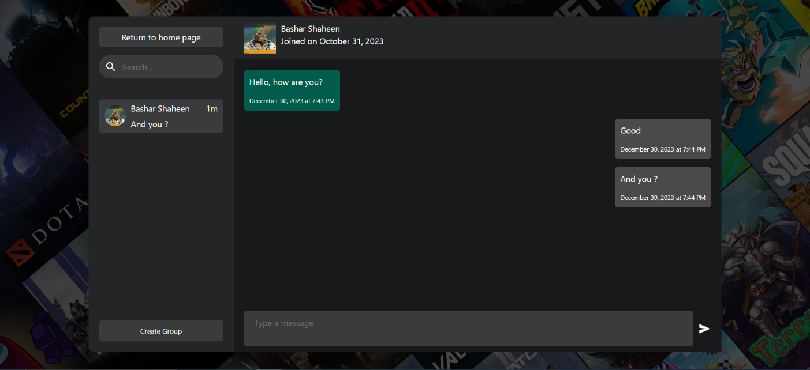

*Figure 16 – chat page*

**Games control page:**

This page is only for admins to view and control current games.

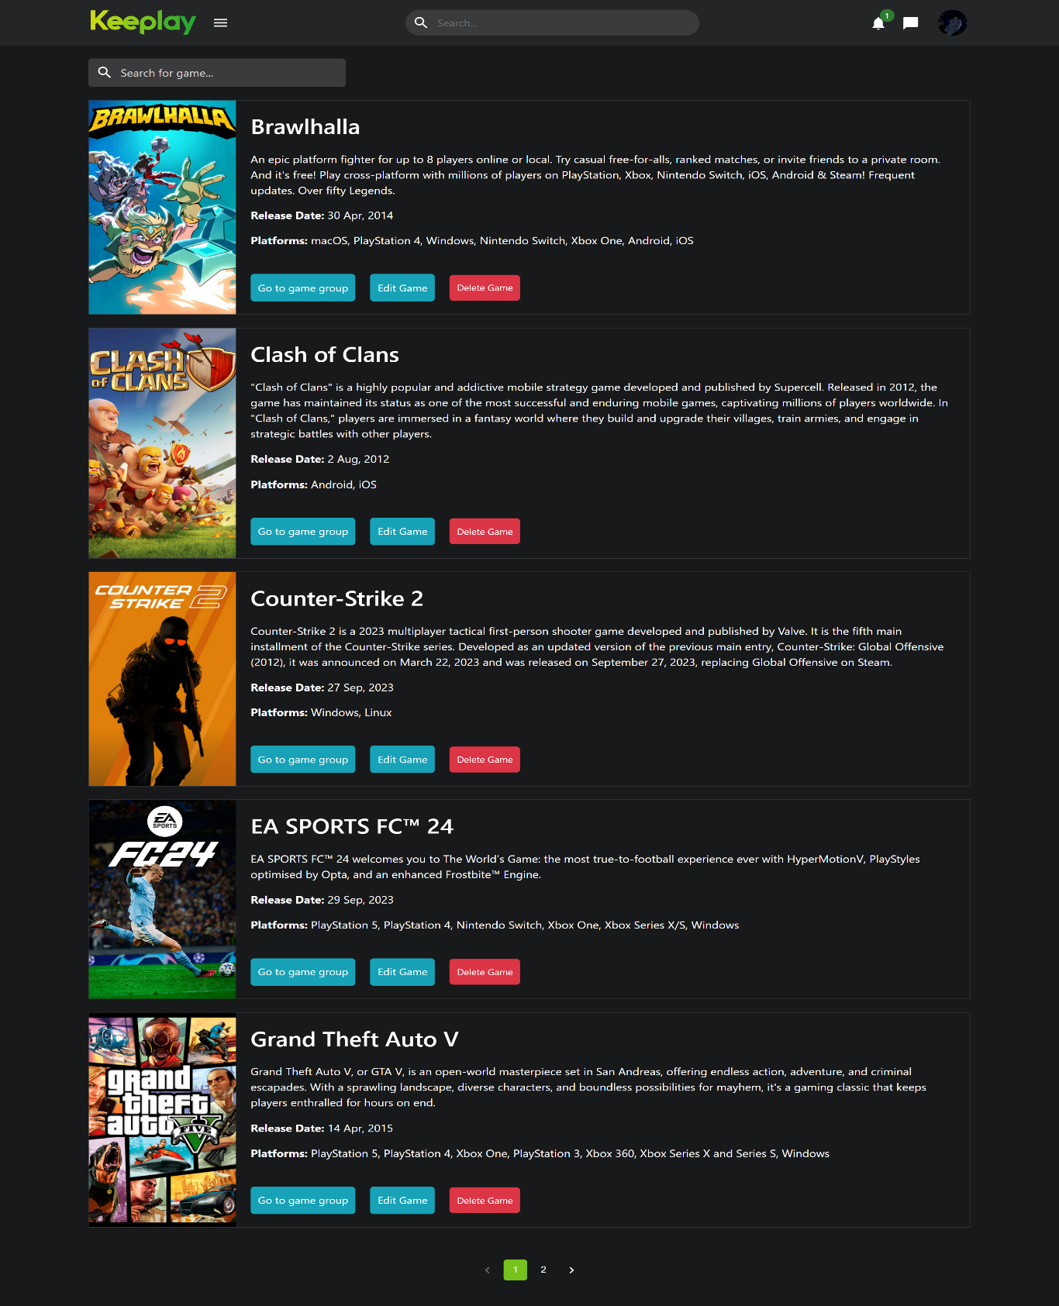

*Figure 17 – games control page*

**Email verify page:**

This page is for response status of verify email.

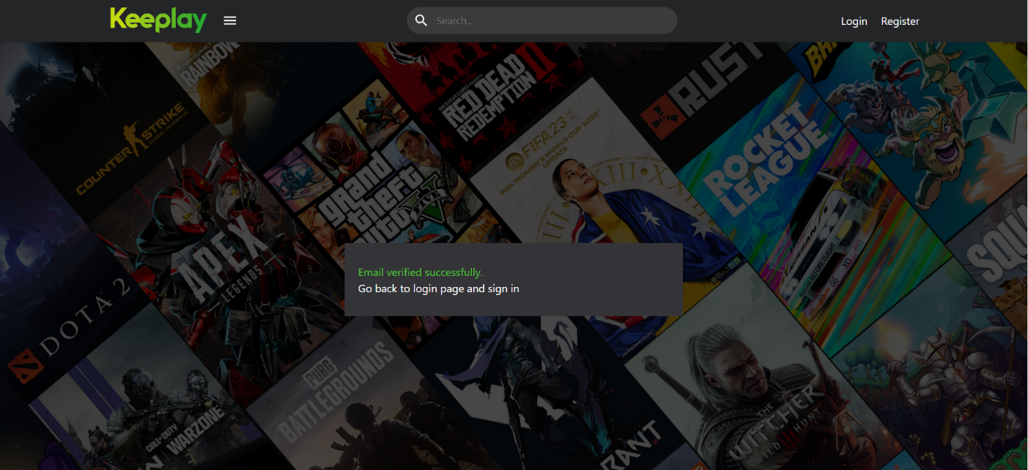

*Figure 18 – email verify page*

**Forget password page:**

This page is for sending email to the user email to reset password.

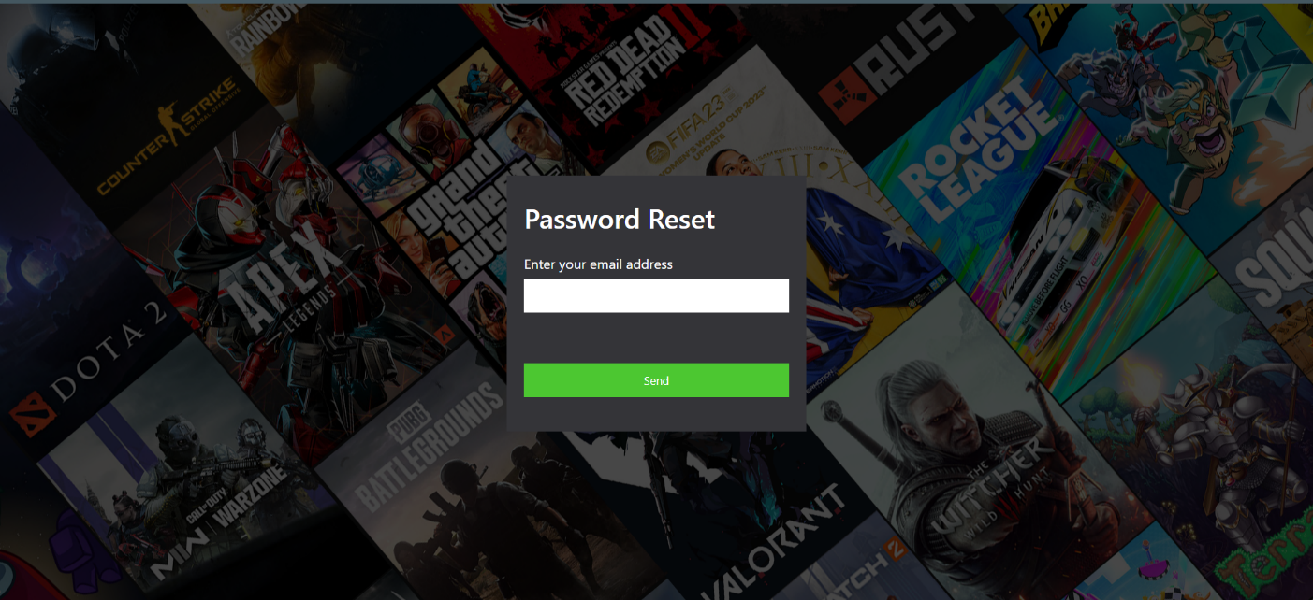

*Figure 19 – forget password page*

**Reset password page:**

This page is for reset password after clicking on the link on your email.

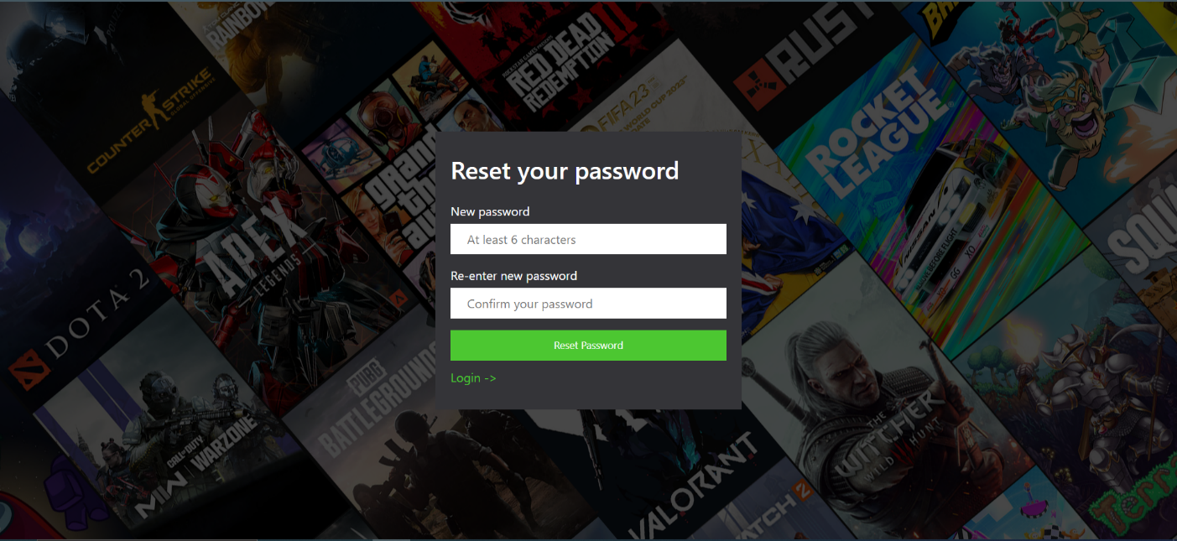

*Figure 20 – reset password page*

**Add new giveaway page:**

This page is only for admins to add new giveaway.

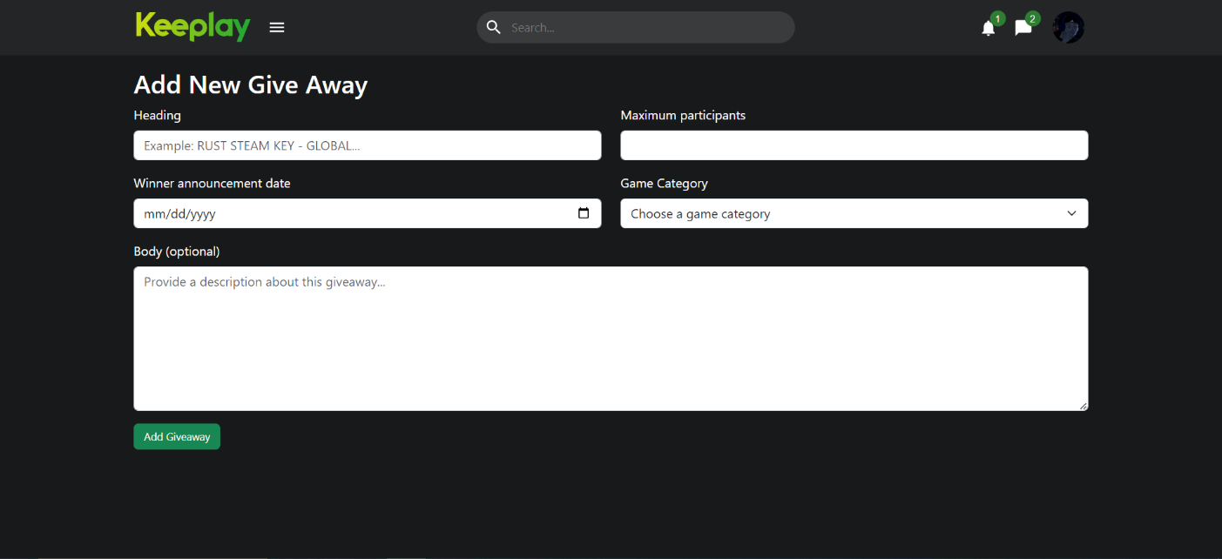

*Figure 21 – add new giveaway page*

**Edit giveaway page:**

This page is only for admins to update a specific giveaway.

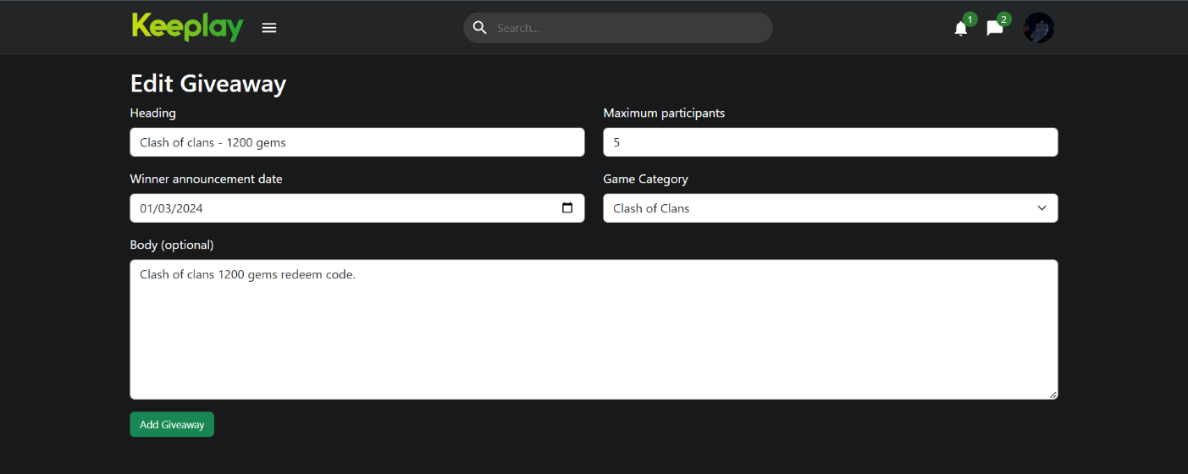

*Figure 22 – edit giveaway page*

**Not found page:**

This page for display 404 for not found URL.

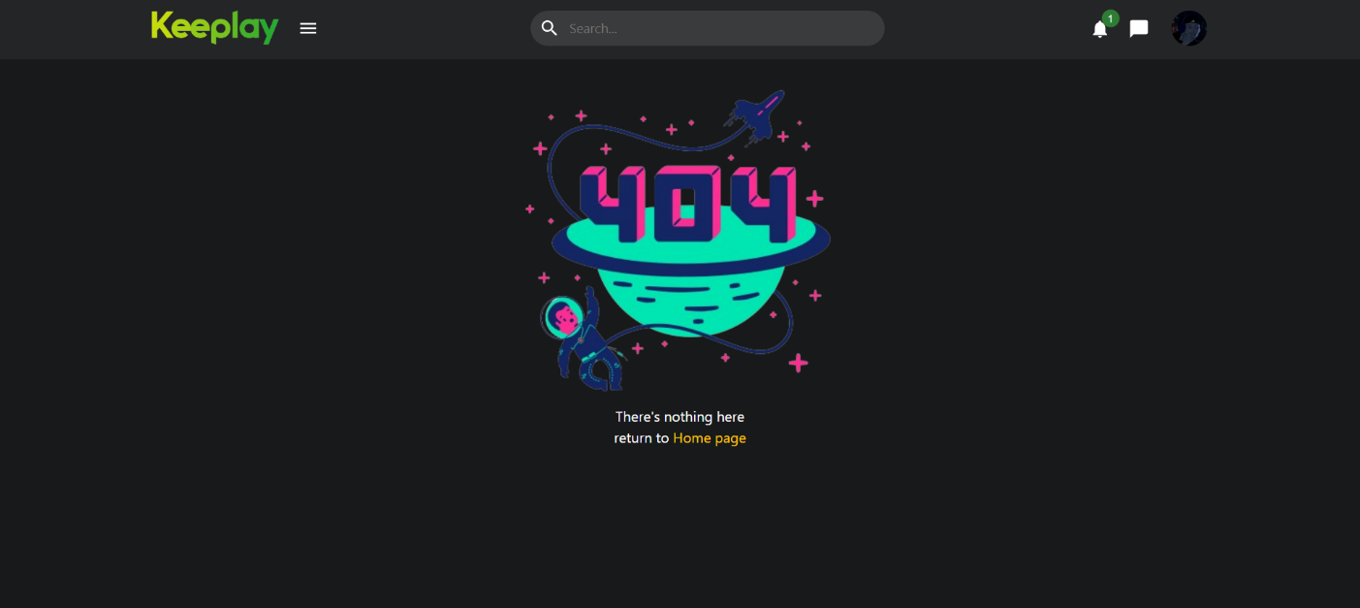

*Figure 23 – not found page*

**Game group page:**

This page to represent game information with topics

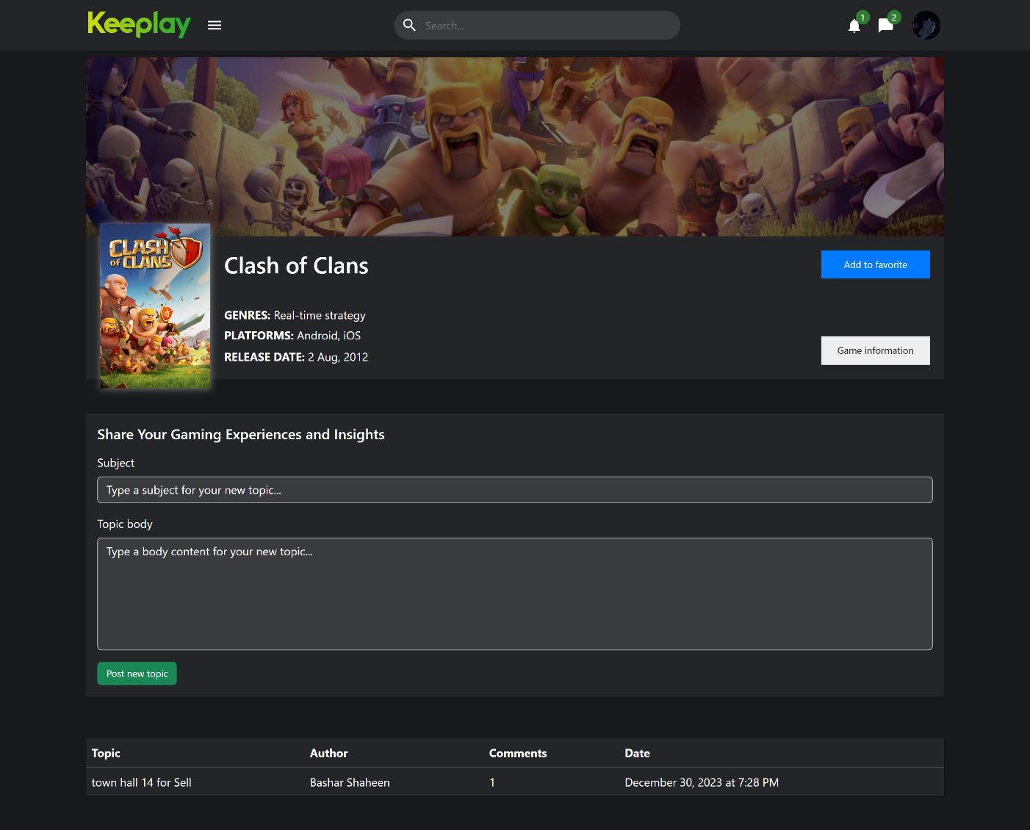

*Figure 24 – game group page*

**Topic page:**

This page represents full topics with comments.

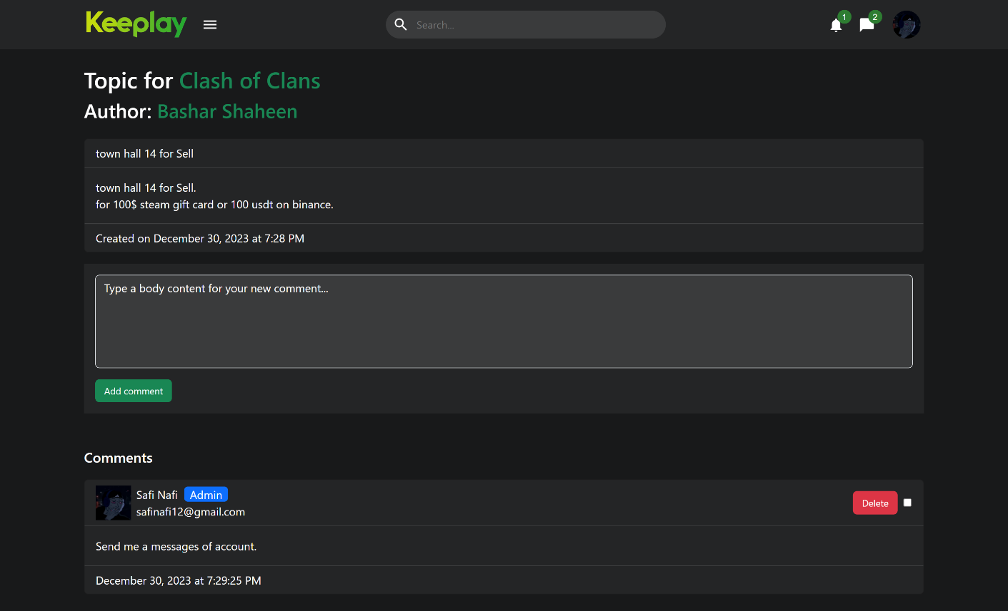

*Figure 25 – topic page*

**Notifications page:**

This page represents notifications for current user.

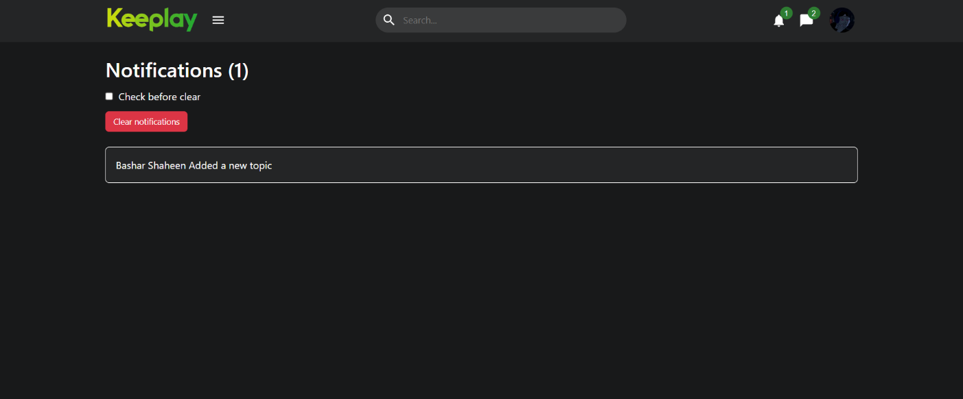*Figure 26 – notification page*

**Chapter 5: Testing**

**5.1 System Testing**

We conducted comprehensive system testing by inviting gamers to participate in various use cases across different locations. Gamers were provided access to the system and asked to provide feedback via a designated platform, regarding their experience using the platform. The collected feedback was analyzed to identify areas for improvement in terms of performance, usability, and user experience.

Specifically, gamers were queried about the ease of performing actions such as adding, deleting, and editing content within the system. Their responses and insights were instrumental in refining and enhancing the system's functionality and user interface to better meet the needs and expectations of the gaming community.

**5.2 Website testing**

We utilize Lighthouse, a Google-developed open-source tool, to perform thorough audits of our gaming social website. Lighthouse assesses key aspects like performance, accessibility, best practices, and SEO tailored for the gaming community. Through these audits, we pinpoint areas for improvement such as game asset loading speeds, accessibility enhancements, adherence to industry standards, and optimized SEO strategies. Insights from Lighthouse testing guide us in enhancing the website's design, functionality, and user experience, ensuring alignment with gamers' expectations and industry benchmarks.

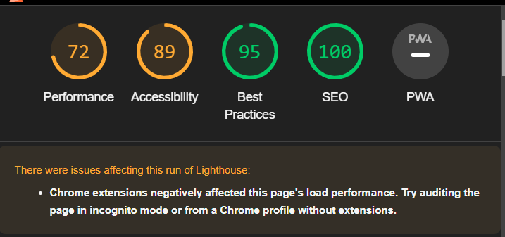

*Figure 27 – website testing lighthouse*

**Chapter 6: Conclusion, Key finding and Future Work**

**6.1 Key Findings**

The outcomes of the project showcase successful user engagement, a diverse and growing community membership, optimized user experience, and a positive community interaction environment. The implementation of gamification features has enhanced user participation, and the website's search engine visibility has steadily improved over time. Challenges such as technical complexities, community moderation, and search engine visibility were addressed through strategic solutions, resulting in a robust and user-friendly gaming community platform.

**6.2 Conclusion**

The Gaming Hub App project has successfully created a space where gaming fans can connect, chat, and share their passion for games. It brings together essential features like chatting, following others, and joining group games, making it easy and fun to use. The app's design is user-friendly, so everyone, whether new or experienced in gaming, can enjoy it. We've worked hard to make sure the app is reliable and enjoyable for all users. Looking ahead, we're excited to keep improving the Gaming Hub App, adding new features and making it even better for our gaming community.

**6.3 Future work**

* Translation for the whole website.
* Improving search algorithm.
* **Advanced Sorting and Filtering**: Implement advanced sorting options for group posts based on criteria such as popularity, relevance, recent activity, and user engagement levels.
* **Add shop section** for website.
* **Upgrade the chat functionality** with new features such as message deletion, reporting capabilities, voice calls, and more.
* **Introduce a new "Live Players' Page"** feature to facilitate user interactions and matchmaking. This feature will function similarly to a queue system, enabling users to easily find and connect with other players who are actively online and available to engage in gameplay.

**Chapter 7: References and technologies**

**7.1 Technologies**

|  |  |
| --- | --- |
| Backend | Frontend |
| Nodejs with express.  Mongo database.  Most important packages:   * node mailer for email sends. * Cron job for schedule functions. * Socket.io for live | React with material-Ui.  CSS with Bootstrap.  Most important packages:   * Axios Api. * react-toastify for toast-message. * socket.io-client |

**7.2 References**

1. “Use case Diagram Tool”, www.visual-paradigm.
2. “Class diagram Tool”, <https://app.quickdatabasediagrams.com/>
3. “Website performance test”, Google lighthouse.